

Univ.-Prof. Dr.  Christof GATTRINGER |  | 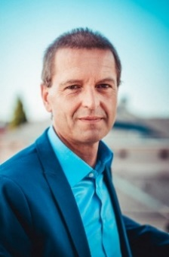
Persönliche Daten
geboren | 1966 in Wien
Berufslaufbahn
seit 2005 | Professor (§ 98) for Theoretical Physics, University of Graz
2004 | Professor (C3) for Theoretical Physics, University of Wuppertal
2000-2005 | Research Assistant, University of Regensburg
1998-2000 | Senior Research Associate, MIT, Cambridge, USA
1996-1998 | FWF Schrödinger Fellow, UBC, Vancouver, Canada
1992-1996 | PhD Fellow, Max-Planck-Society, MPI Werner-Heisenberg-Institute, Munich
01/2013-07/2013 | Visiting Research Scholar, University of Washington, Seattle, USA
Ausbildung
2002 | Habilitation in Theoretical Physics, University of Graz
1995 | PhD in Physics, University of Graz
1992-1995 | Dissertation at the MPG Werner-Heisenberg-Institute, Munich
1986-1992 | Study of Physics and Mathematics, University of Graz
1984-1986 | Study of Mechanical Engineering, TU Graz
Mitgliedschaften
Seit April 2021 | President of the Austrian Science Fund FWF
10/2019-05/2021 | Vice Rector for Research and Career Development
2015-2019 | Dean, Faculty of Natural Sciences
2009-2015 | Vice Dean for Research, Faculty of Natural Sciences
2009-2019 | Speaker of an FWF-funded Doctoral College in Particle Physics
2007-2009 | Head of the Theoretical Physics Division, Institute of Physics
Auszeichnungen
 | Author/Co-Author of 185 scientific publications
 | Advanced textbook on Lattice Quantum Field Theory (with C.B. Lang)
 | Principal Investigator in more than 20 funded research projects
 | More than 130 scientific talks at conferences, workshops and seminars
 | Ludwig Boltzmann Award of the Austrian Physical Society
 | Regular refereeing for several physics journals and funding agencies
 | Advisor of 16 PhD theses and 22 Master- und Diploma-theses

